**March 14th, 2025**

**Hon. Miss Santia J. O. Bradshaw, M.P.**

Deputy Prime Minister

Minister of Transport and Works

Pine East-West Boulevard

The Pine

**ST. MICHAEL**

Dear Madam,

I have the honour to inform you of the following measures passed at the **99th Sitting** of the Honourable the House of Assembly held on **Monday, February 17th, 2025:**

1. Social Empowerment Agency Bill, 2025.
2. A Resolution to grant the sum of $2,288,465 from the Consolidated Fund and to place it at the disposal of the Government to supplement the Estimates 2024-2025 as shown in the Supplementary Estimates No. 1 2024-2025.
3. A Resolution to grant the sum of $329,314,104 from the Consolidated Fund and to place it at the disposal of the Government to supplement the Estimates 2024-2025 as shown in the Supplementary Estimates No. 2 2024-2025.
4. A Resolution to grant the sum of $14,154,094 from the Consolidated Fund and to place it at the disposal of the Government to supplement the Estimates 2024-2025 as shown in the Supplementary Estimates No. 3 2024-2025.
5. Appropriation Bill, 2025.
6. Resolution to approve in accordance with section 5 of the Crown Lands (Vesting and Disposal) Act, Cap. 225 the vesting in the African Export-Import Bank of a parcel of land, situate at Jemmotts Lane in the parish of Saint Michael in the Island, the site of the old Barbados General Hospital for the construction of the African Export-Import Bank (Afreximbank) African Trade Centre.

Also, a Ministerial Statement was delivered by Dr. the Hon. William F. Duguid, J.P., M.P. on the proposed sale and development of the site of the Holetown Civic Centre, St. James.

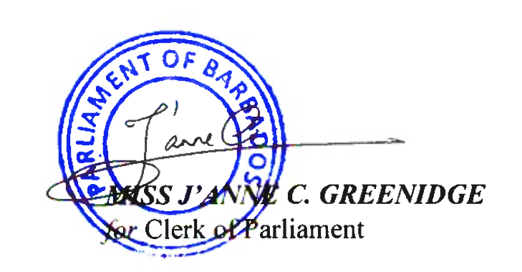Yours faithfully,

**cc. Senator the Hon. Ms. Lisa R. Cummins**

**Minister of Energy and Business**

**Leader of Public Business in the Senate**