**March 21st, 2025**

**Senator the Hon. Ms. Lisa R. Cummins**

Minister of Energy and Business

Ministry of Energy

Country Road

**ST. MICHAEL**

Dear Madam,

I have the honour to inform you of the following measures passed at the **58th Sitting** of the Honourable the Senate held on **Friday, March, 14th, 2025:**

1. Social Empowerment Agency Bill, 2025;
2. Rural and Urban Development Commission Bill, 2025;
3. Appropriation Bill, 2025; and
4. A Resolution to approve in accordance with section 5 of the *Crown Lands (Vesting and Disposal) Act,* Cap. 225 the vesting in the African Export-Import Bank of a parcel of land situate at Jemmotts Lane in the parish of Saint Michael in this Island for the construction of the African Export-Import Bank African Trade Centre.

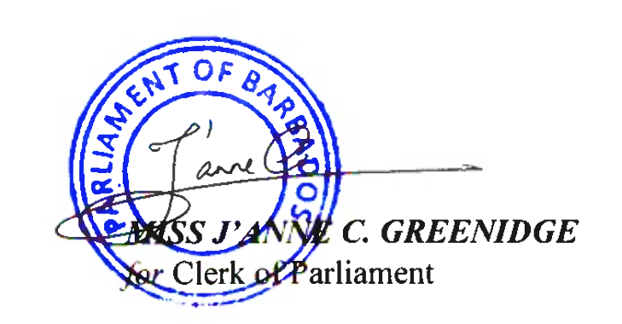Yours faithfully

**cc. Hon. Miss Santia J. O. Bradshaw, M.P.**

**Deputy Prime Minister, Minister of Transport and Works**

**Leader of the House of Assembly**